Performance Measurement

1. Performance Valuation

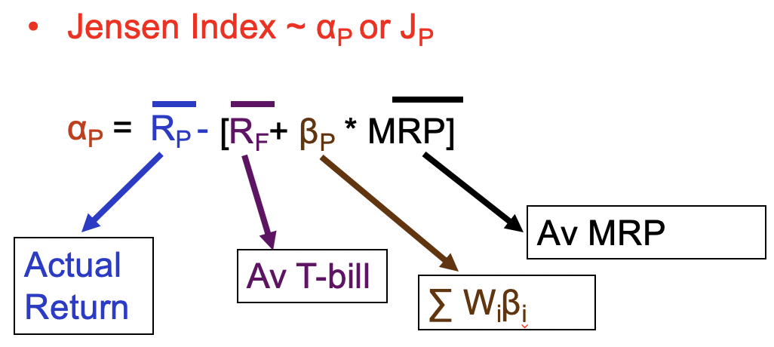

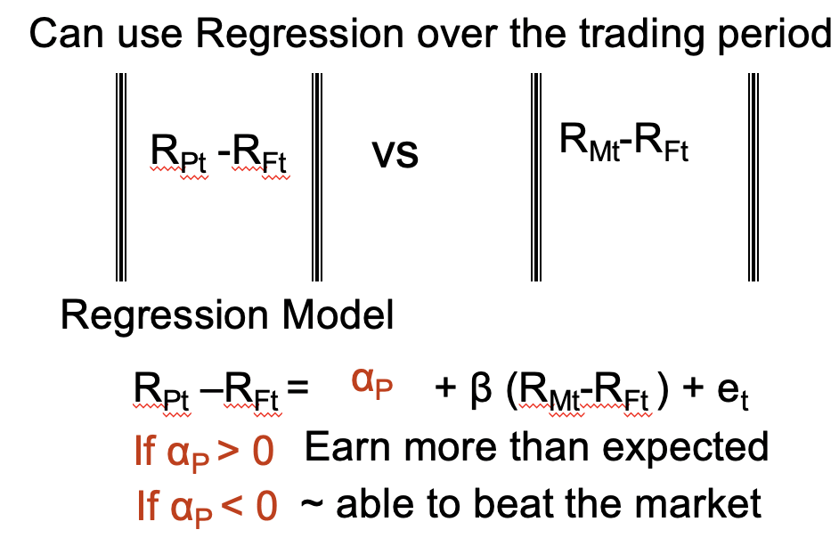

<Example>

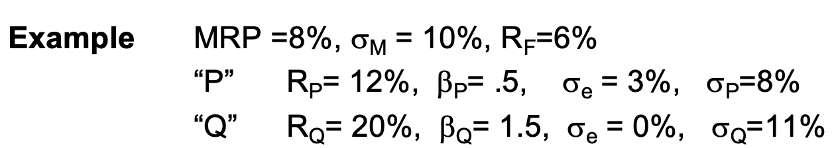

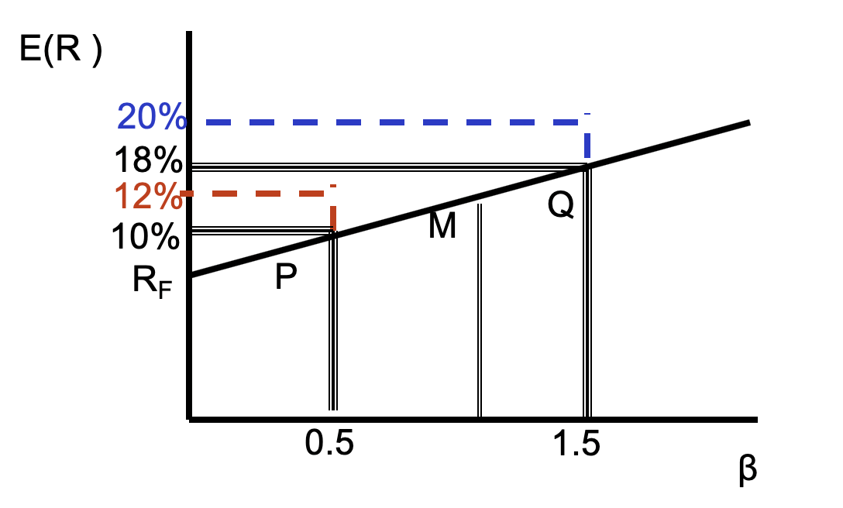

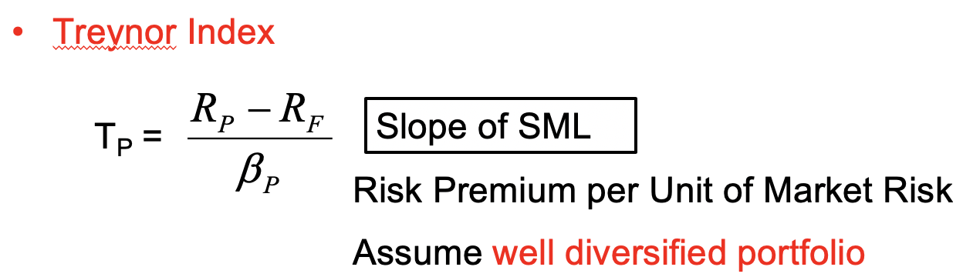

Ignore unsystematic risk

<Example Revisited>

Tp=(12-6)/0.5=12 TQ=20-6/1.5=9.3

If believe in CAPM, use Treynor to rank managers.

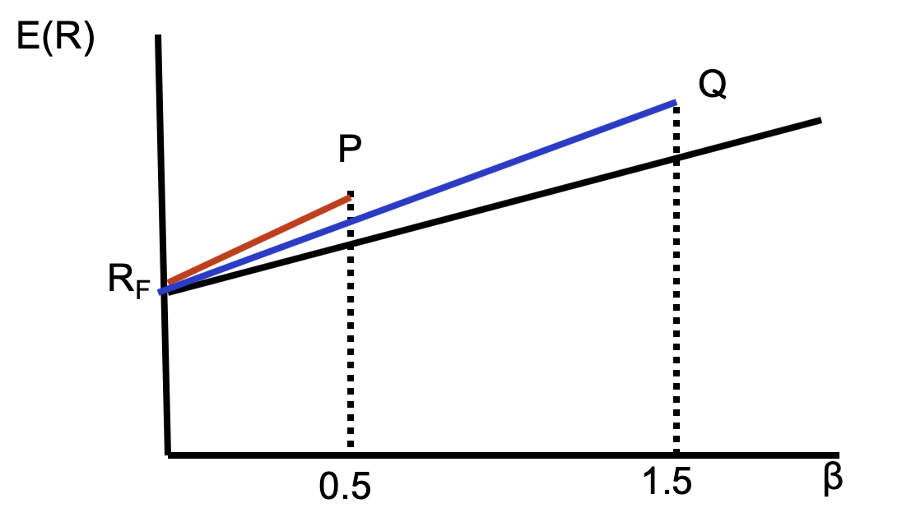

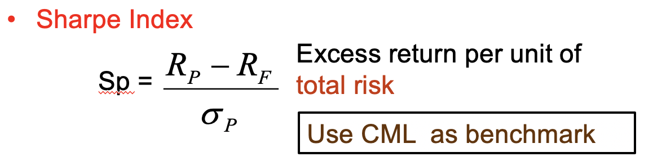

<Example Revisited>

Sp=(12-6)/8=0.75 SQ=20-6/11=1.25

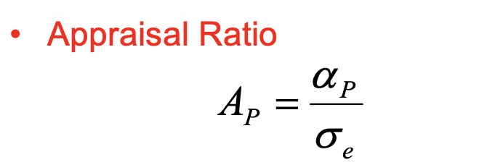

<Example Revisited>

AP=2%/3%=0.67 AQ=2%/0%=INF

Biased toward diversified portfolio

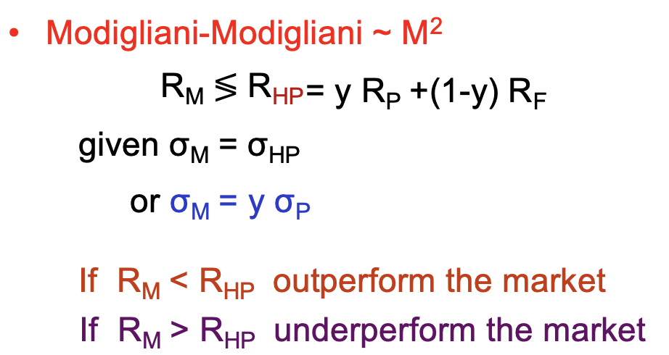

<Revisited Example>

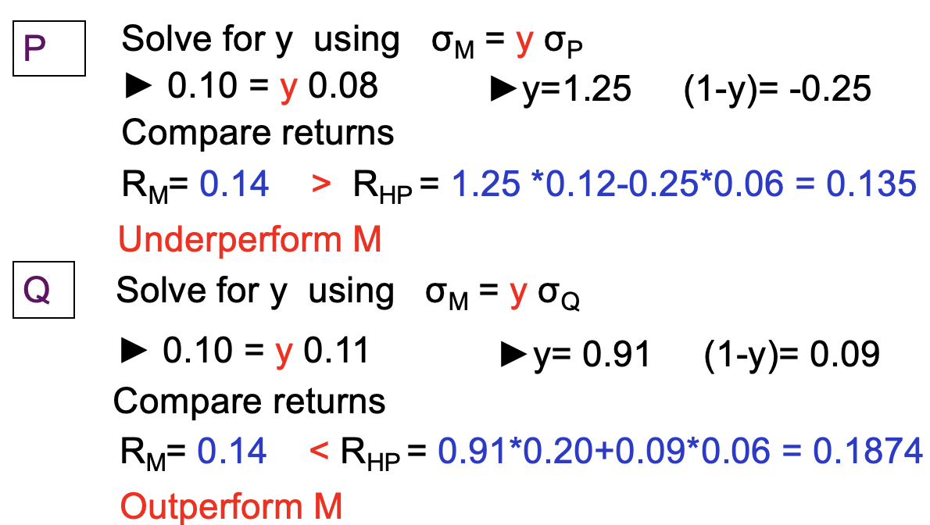

The underlying model is CML (sigma)

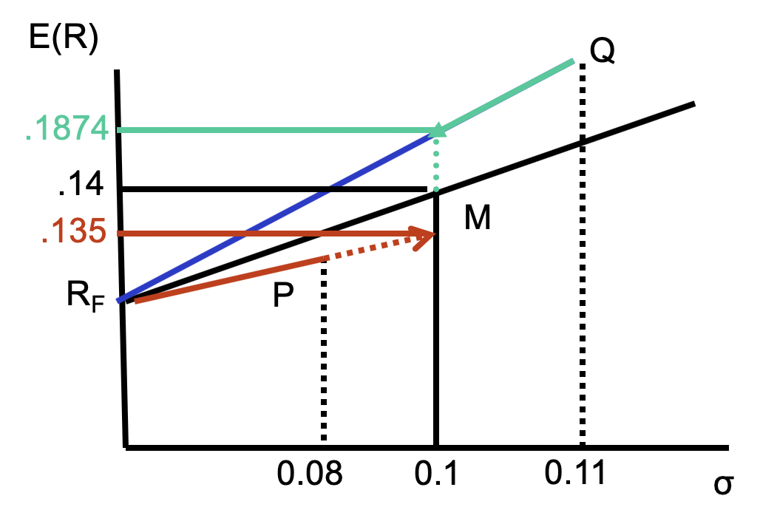

**2. Performance Attribution**

Look at the decisions **Asset Allocation, Stock Selection** that result in **superior** or **inferior** performance

<Example>

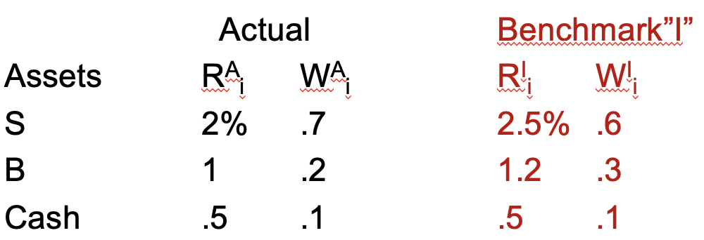

Actual return = 2%*0.7 + 1%*0.2 + 0.5%*0.1 = 1.65%

Benchmark return = 2.5%*0.6 + 1.2%*0.3 + 0.5*0.1 = 1.91%

1.65% - 1.91% = -0.26% or -26bp (1% = 100 base points)

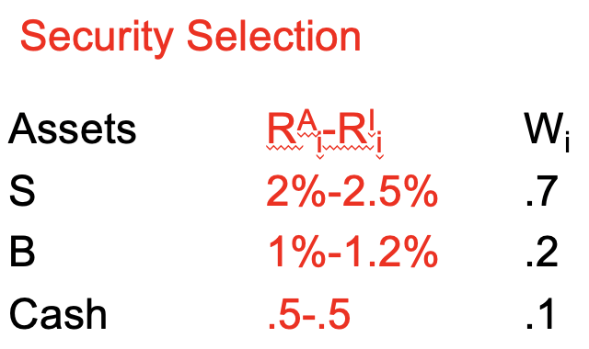

Security selection = -0.5%*0.7 – 0.2%*0.2 = -0.39% or -39bp

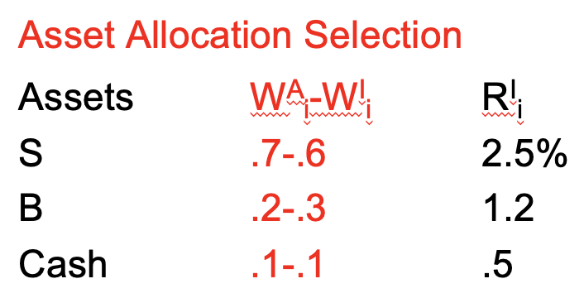

Asset allocation = 136bp